三、吸收薄膜电容器

**型号命名：**RT8568A *** **** ***

**详细参数：**（详见样本）

|  |  |  |
| --- | --- | --- |
| 容量范围  Capacitance range | 0.047μF~50μF | |
| 额定电压  Rated Voltage | 630 VDC~3000 VDC | |
| 电容量允许偏差  Capacitance Tolerance | J:±5％ ，K:±10％ | |
| 介质损耗角正切  Dissipation factor tgδ（in 10-3 at 20℃） | |  |  |  |  |  | | --- | --- | --- | --- | --- | | at | CN ≤0.1μF | 0.1μF＜CN ≤1μF | CN ＞1μF | CR ＞1μF | | 1 KHz  10 KHz  100KHz | -  -  5.0 | 0.5  0.8  - | 0.5  1.5  - | 0.5  1.5  - | | |
| 绝缘电阻  Insulation Resistance (at 20℃ 100VDC,60S) | CN ≤0.33μF | CN ＞0.33μF |
| 100 GΩ | 30000s |
| 运行温度范围  Operating temperature range | -40 °C~ 85 °C | |
| 贮存温度范围  Storage temperature range | -40 °C~ 105 °C | |
| 耐电压  Voltage Endurance | 极间 Between Terminals：1.6UN(10s) | |
| 安装  Installation | 任意方向 Any position | |
| 最大电极扭矩  Max torque of electrode | / | |
| 最大安装扭矩  Max torque of installation | / | |
| 湿度  Humidity | 95% （T test=56days） | |
| 最高使用海拔  Maximum Altitude | 2000m | |
| 预期寿命  Lifetime Expectancy | 100 000 h @UN ;θhotspot≤70℃ | |

**产品图片：**

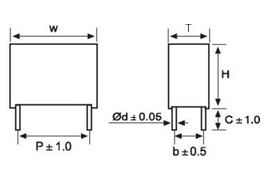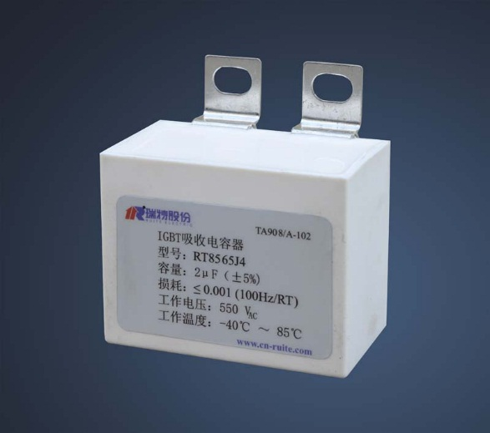

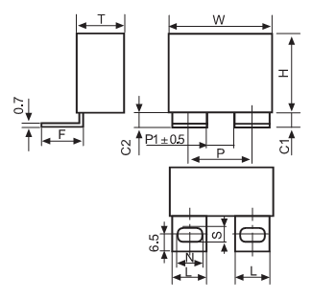

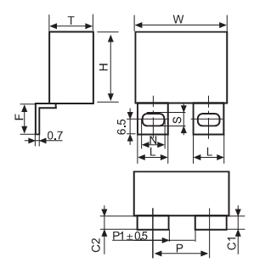

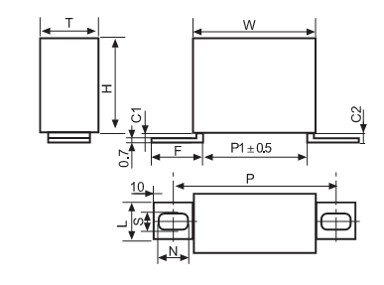

**操作说明：**

/

**原理框图：**

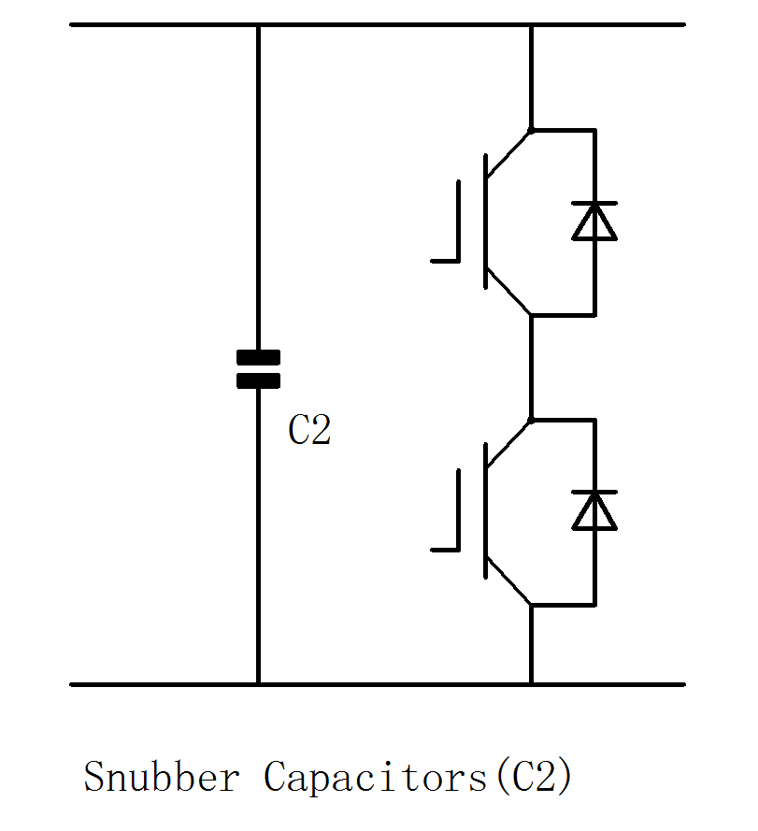

**附件配件：**

/